Steinbach Arts Council HSD Newsletter Submission – Submitted November 24, 2021
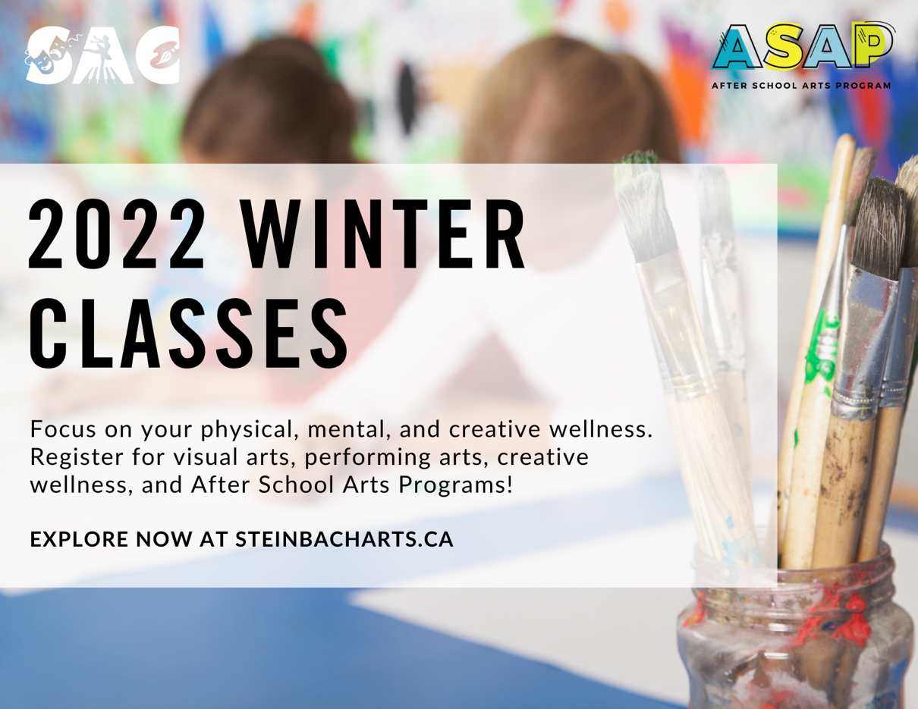

At the Steinbach Arts Council, we're working to make physical, mental and creative wellness a reality in all our programming. Find a class that will challenge and keep you inspired in the cold, winter months!

Visit our website for a full list of winter programs, keeping you safe, healthy and creative, all season long! Looking for free after school arts programs? Explore steinbacharts.ca or call 346-1077 for more info.

