CMS Fall Drive
The Grade 5 Mini-MAC team is working together with Community Outreach and Steinbach Family Resource Center to help families in our community.
We would love and appreciate any help you can offer. To make it a little more interesting and focused on various items, we have broken down the needs to specific days, but feel free to donate whatever and whenever you are able to. We will be collecting these donations between November 20th and 26th.

Winter Wednesday- gently used or new outdoor wear such as mitts, scarves, hats, and jackets.
Toiletry Thursday- toiletries such as soap, shampoo, toothpaste, toothbrushes, deodorant, etc...
Food Friday- non-perishable food items such as soup, pasta, rice, cereal, coffee, tea, juice, canned fruit or vegetables, pickles, applesauce, pasta sauces, crackers, cookies, boxed Jello or pudding, etc…
Munchkin Monday- baby items such as wipes, diapers, creams, baby shampoos, baby food, etc…
TP Tuesday- toilet paper packages (it would be neat to see a TP tower built in each classroom).

Items can be brought to each of the classrooms and the Mini-MAC team will collect them daily.
Thank you very much for your support!!! We appreciate you and all that you are able to donate!
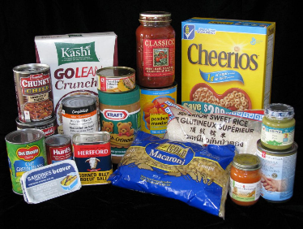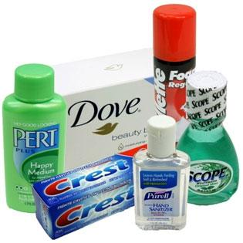

Sincerely,
The Mini-MAC team and CMS

CMS Fall Drive  When:Wed.Nov.20th- Wed.Nov.26th  Drop off at the designated table in your neighbourhood.  Prize for the neighbourhood with the most toilet paper.  Winter Wednesday- gently used or new outdoor wear such as mitts, scarves, hats, and jackets.  Toiletry Thursday- toiletries such as soap, shampoo, toothpaste, toothbrushes, deodorant, etc…  Food Friday- non-perishable food items such as soup, pasta, rice, cereal, coffee, tea, juice, canned fruit or vegetables, pickles, applesauce, pasta sauces, crackers, cookies, boxed Jello or pudding, etc…  Munchkin Monday- baby items such as wipes, diapers, creams, baby shampoos, baby food, etc…  TP Tuesday- toilet paper packages (it would be neat to see a TP tower built in each classroom). | CMS Fall Drive  When:Wed.Nov.20th- Wed.Nov.26th  Drop off at the designated table in your neighbourhood.  Prize for the neighbourhood with the most toilet paper.  Winter Wednesday- gently used or new outdoor wear such as mitts, scarves, hats, and jackets.  Toiletry Thursday- toiletries such as soap, shampoo, toothpaste, toothbrushes, deodorant, etc…  Food Friday- non-perishable food items such as soup, pasta, rice, cereal, coffee, tea, juice, canned fruit or vegetables, pickles, applesauce, pasta sauces, crackers, cookies, boxed Jello or pudding, etc…  Munchkin Monday- baby items such as wipes, diapers, creams, baby shampoos, baby food, etc…  TP Tuesday- toilet paper packages (it would be neat to see a TP tower built in each classroom).
CMS Fall Drive  When:Wed.Nov.20th- Wed.Nov.26th  Drop off at the designated table in your neighbourhood.  Prize for the neighbourhood with the most toilet paper.  Winter Wednesday- gently used or new outdoor wear such as mitts, scarves, hats, and jackets.  Toiletry Thursday- toiletries such as soap, shampoo, toothpaste, toothbrushes, deodorant, etc…  Food Friday- non-perishable food items such as soup, pasta, rice, cereal, coffee, tea, juice, canned fruit or vegetables, pickles, applesauce, pasta sauces, crackers, cookies, boxed Jello or pudding, etc…  Munchkin Monday- baby items such as wipes, diapers, creams, baby shampoos, baby food, etc…  TP Tuesday- toilet paper packages (it would be neat to see a TP tower built in each classroom). | CMS Fall Drive  When:Wed.Nov.20th- Wed.Nov.26th  Drop off at the designated table in your neighbourhood.  Prize for the neighbourhood with the most toilet paper.  Winter Wednesday- gently used or new outdoor wear such as mitts, scarves, hats, and jackets.  Toiletry Thursday- toiletries such as soap, shampoo, toothpaste, toothbrushes, deodorant, etc…  Food Friday- non-perishable food items such as soup, pasta, rice, cereal, coffee, tea, juice, canned fruit or vegetables, pickles, applesauce, pasta sauces, crackers, cookies, boxed Jello or pudding, etc…  Munchkin Monday- baby items such as wipes, diapers, creams, baby shampoos, baby food, etc…  TP Tuesday- toilet paper packages (it would be neat to see a TP tower built in each classroom).

